CHESS

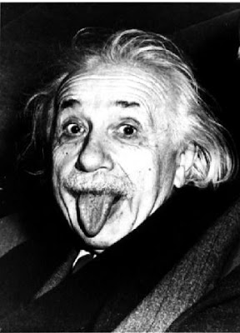
"Chess holds its master in its own bonds, shackling the mind and brain so that the inner freedom of the very strongest must suffer."
- Albert Einstein
School in Movement: enjoying wealth being in good health
Project Number: 2014-1-ES01-KA201-003518_4

The integrated laboratory of chess, played for the Erasmus program, has brought the students to compete with each other, stimulated by the teacher who has always tried to transform competitiveness into a moment of reflection. The fundamental objectives were to: improve creativity, expression and intuition which have been amply achieved. To promote the educational aspect of group work, important to address the various tournaments that are organized throughout the all project period. Chess is the best sport to exercise the most important organ in our body, the brain. Although this game might not help you build your biceps or tone your abs, it actually is an incredibly beneficial pastime, because playing chess results in better brain function, improved memory and cognitive abilities, strategic thinking and attention improvement. All of these benefits are directly related to the practice of chess, both in real-life and in virtual environments.
Playing chess gives a lot of benefits, like: - increasing creativity: playing chess helps unleash your originality, since it activates the right side of the brain, the one responsible for creativity;
- improving memory: Chess players know that playing chess improves their memory, mainly because of the complex rules to remember, as well as the memory recall needed when trying to avoid previous mistakes or remembering a certain opponent’s playing style. Good chess players have usually exceptional memory performance and recall.
-Teaching planning and foresight : Chess is considered to be a strategy game. This means that, in order to win, you must have a better plan of action than your opponent. Therefore, playing chess greatly improves the ability to develop certain strategies and plans. A good strategic mind is really productive because it creates the best plan of action for every daily task. Also, strategic thinking can be a life savior in academic and work environments, because everything is planned one step ahead and there’s always a plan B;
- improving brain function : the brain is responsible for our mental performance and it is the most crucial organ in the human body. When the brain has no stimulation, the cells inside slowly die. However chess is a tool which gives users a rigorous mental workout. Studies show that in order to play chess well, a player must develop and utilize his or her brain’s left hemisphere. Over time, thanks to the rules and techniques involved in the game, playing chess will effectively exercise and develop not one but both sides of the brain;
-Improving attention : Chess demands attention. In other words, if your mind is not focused on the game, you lose: simple as that. With such an immediate punishment for a lack of attention, the mind is trained to be focused and attentive. This results in a better performance in schools and workplaces, in less time wasted and more victories achieved;
-Resilience: When a situation becomes difficult, often gives way under the weight of the difficulties. Chess teaches you to get to the bottom and to fight to the end. This can also teach that in the most difficult periods of life, it’s useless turn in on themselves and get depressed, but it is better to engage in activities pleasant and allow us to look at things with more optimism .
-Having faith in yourself and in your intuitions: When you are playing chess, you are forced to make important decision, being influenced only by your own judgement. Chess is a game where you learn to take calculated risks, but sometimes you can’t get a clear view of the situation and you makes a move using the power of intuition and not that of pure calculation;
The game of chess has a high educational, cultural and educational value. It is a mental game that overcomes social barriers, and that can be played at any age, helping us to reflect and to navigate around complex systems.
Edited by Gaia Barbari

