**PROJECT 2014-1-ES01-KA201-003518_4 “ School in Movement: enjoying wealth being in good health”**

**Chess Newsletter**

 **On 21st December 2016**, third year of our project, the fifth round of the International Chess Tournament took place. The competition started at around midday. Our school mate Luca Crescentini took part in it. This is the photo of the class he belongs to, the 5th A of the scientific section.

*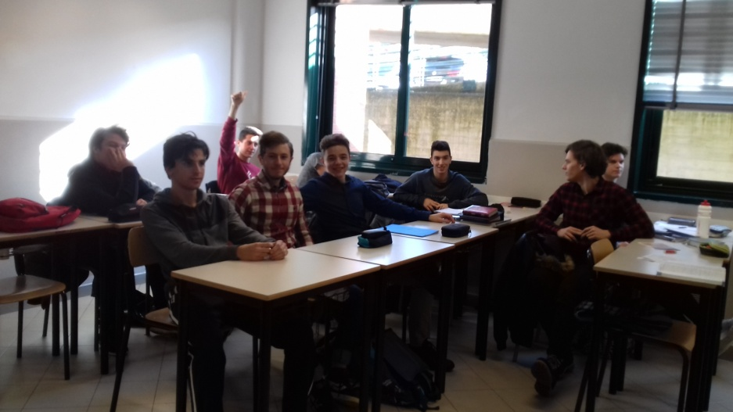Luca is ready and can’t wait to begin. As you can see it’s a small class – their number has been gradually cut down in the last years- the remaining ones will take their final State Exam in June of this school year.*

The first round of the tournament is being played by the Spanish and the Latvian players. The next pictures show Luca while waiting for his turn, he got permission from his Art Teacher to play on the class computer and the match is on White Board.

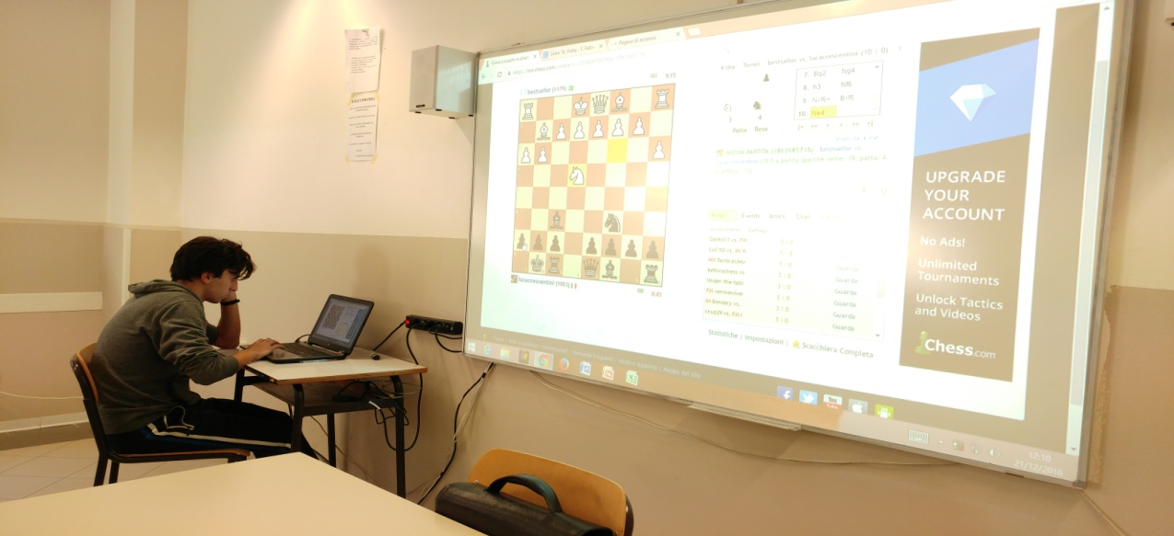

The tournament was played on line. Like on the other occasions, Luca registered on **Chess.com** accepting the invitation from our coordinator Sonia Pita from Spain. The contest went on for a few days. The first two players, the Latvian and the Spanish finished their round on Christmas Day. Luca was supposed to play with the Turkish contestant simultaneously, but he didn’t take part unfortunately. So Luca had to wait for his turn until the 25th when he started his match with the Latvian boy who won the tournament. Congratulation Tereray! Luca Crescentini got second, though. Well done Luca! Thanks to all the people who made this event possible, from teachers to students, to the photographers.

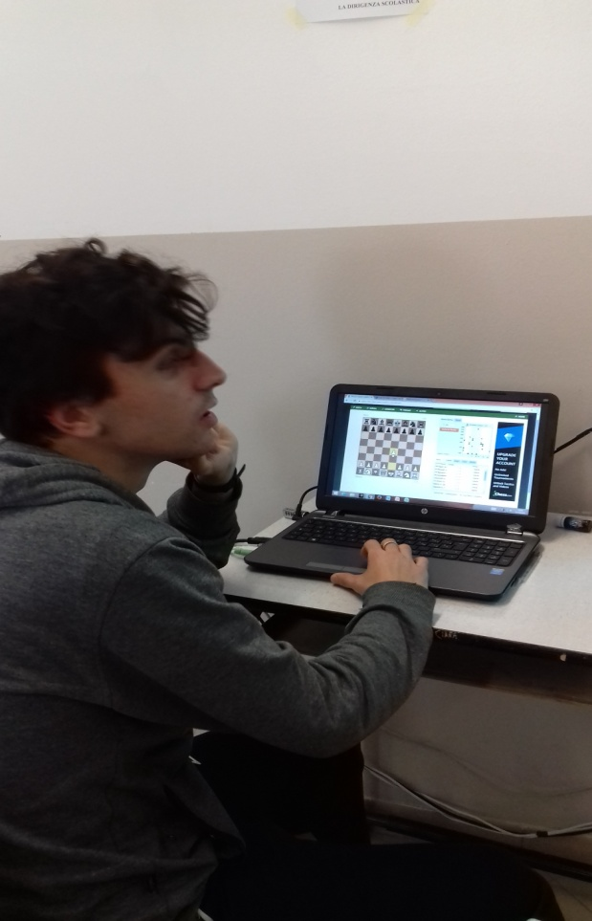

**Standings Chess.com**

[Standings](https://www.chess.com/tournament/fifth-school-in-movement-tournament/players)

| Player | | Record | Final Round | Tie Break |
| --- | --- | --- | --- | --- |
| #1 | [tereray](https://www.chess.com/member/tereray)  [**tereray**](https://www.chess.com/member/tereray)  (1823)  (32 points awarded) | 4 - 0 - 0 | 2 ▸ 2 | 0 |
| #2 | [lucacrescentini](https://www.chess.com/member/lucacrescentini)  [**lucacrescent...**](https://www.chess.com/member/lucacrescentini)  (1202)  (16 points awarded) | 0 - 0 - 2 | 2 ▸ 0 | 0 |
| #3 | [fisicoquimico32](https://www.chess.com/member/fisicoquimico32)  [**fisicoquimic...**](https://www.chess.com/member/fisicoquimico32)  (983) |  |  |  |

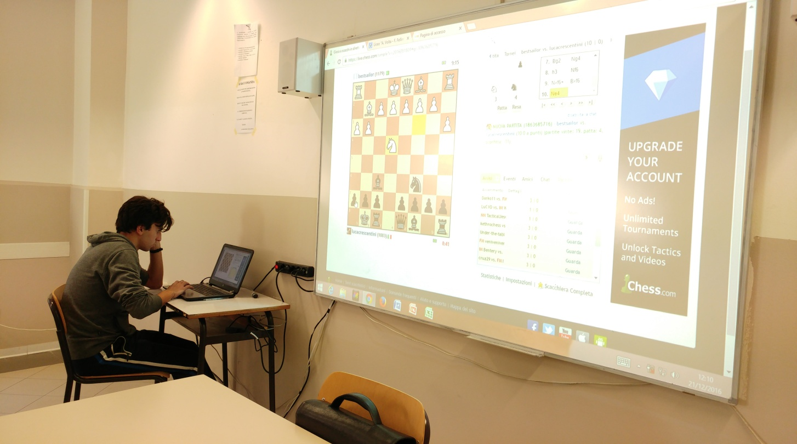

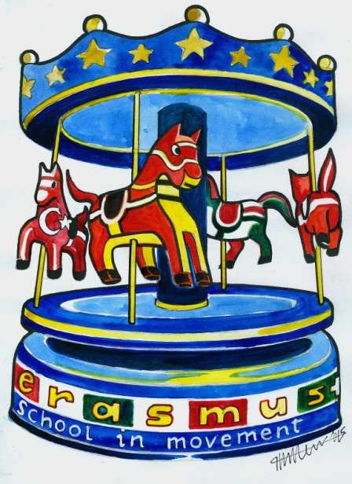 ***Edited by Zappia Ilaria 5th Ds***