An Erasmus Plus Project
Number: 2014-1-ES01-KA201-003518_4
School in Movement:
enjoying wealth being in good health
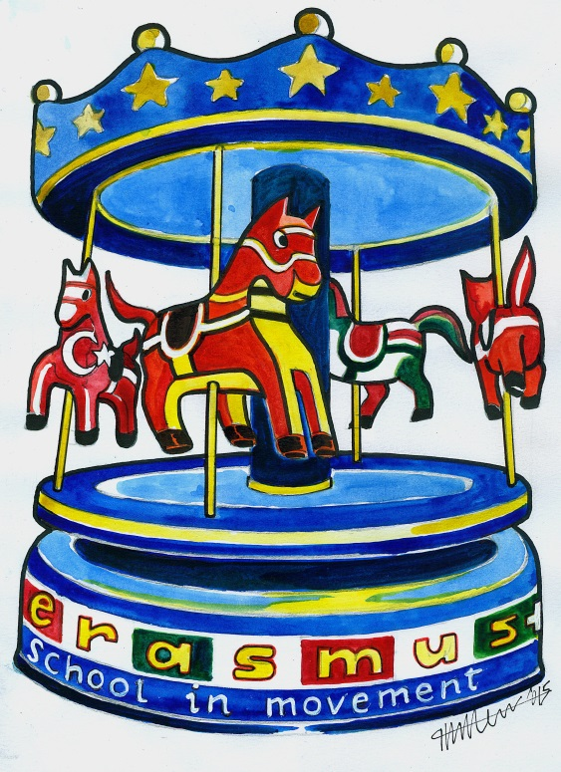

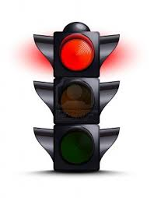
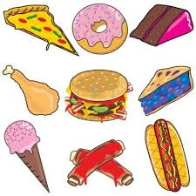

1- Don’t eat junk food, never skip meals;
2- Don’t take drugs, don’t drink alcohol, don’t smoke;

3- Don’t lead a sedentary life;

4- Don’t indulge into a disordered life cycle;
+h+ +++ 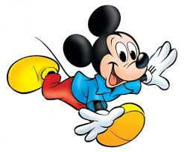
+ +
5- Don’t overdo in doing sport.

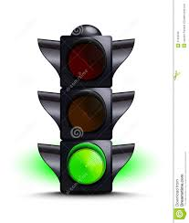

1- Lead a regular life cycle with enough sleep at night;
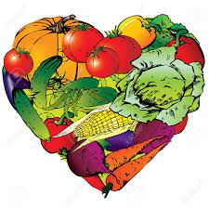
2- Eat healthy and varied food with plenty of vegetable and fruit;

3- Do regular physical exercise and pay attention on your posture;

4- Protect your body and stimulate your mind;

5- Be aware of your and other people’s needs.

