We are working to organize the Solidarity Match to support the Onlus association "Cattolica per la Tanzania", that will be held on March 9, 2016. In order to help this association we have already collected some clothes. We have posted this event on the Erasmus+ facebook page.

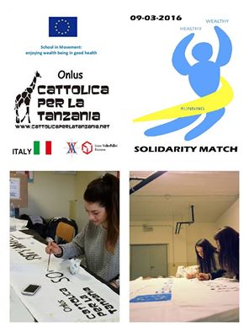

SCHOOL IN MOVEMENT:ENJOYING WEALTH BEING IN GOOD HEALTH
Project number: 2014-1-ES01-KA201-003518_4

