

**School in Movement: enjoying wealth being in good health**

Project Number: 2014-1-ES01-KA201-003518_4 Edited by class 3rd As

**News Letter of the 3rd Solidarity Cause 2017**

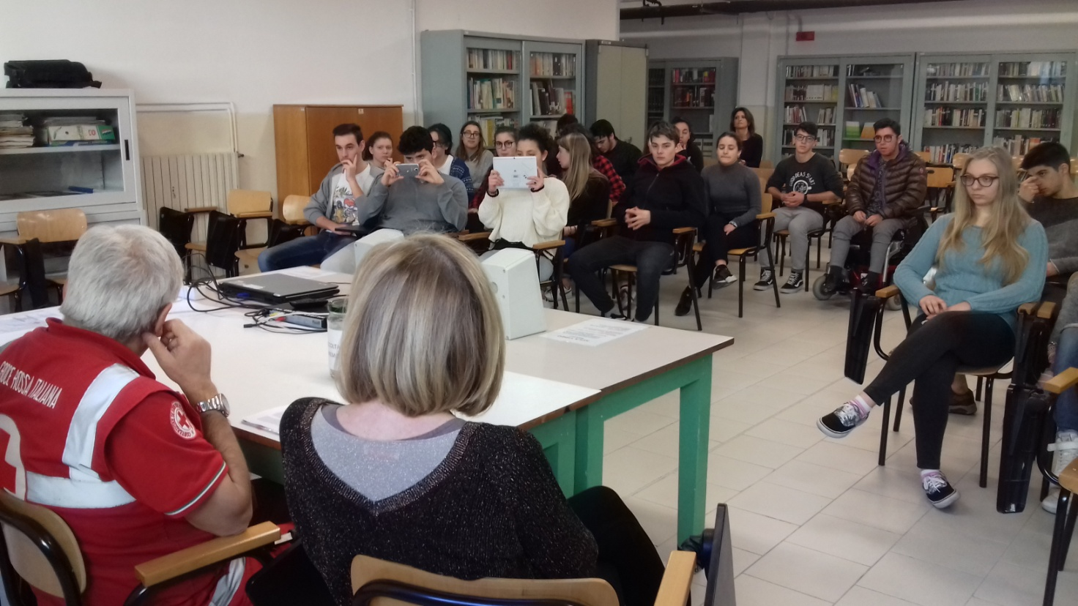

When the new year started we began thinking about the new solidarity cause, the third of the project. We knew that the population of the Centre of Italy was still in serious distress because of the earthquake. We had been watching the constant news on their dramatic situation on TV: lots of families without a home, buildings and farms completely destroyed, rain, cold and a lot of snow on the mountains of central Italy. People in these areas had to move into temporary shelters, mostly big tents where they felt lonely, cold and worried all the time about their possessions and their future.

So we decided to contact the Red Cross of Riccione to ask how we could help and in particular we met with Dr. Antonio Manzo, President of the local Red Cross. He told us that there was a particular village, called Sarnano in the region of Marche, whose mayor was particularly active and energetic with a great sense of hope and optimism. Dr. Manzo had been sent a project for the re building of a Centre for disabled young guys and suggested that we devote our new solidarity cause to this special project.

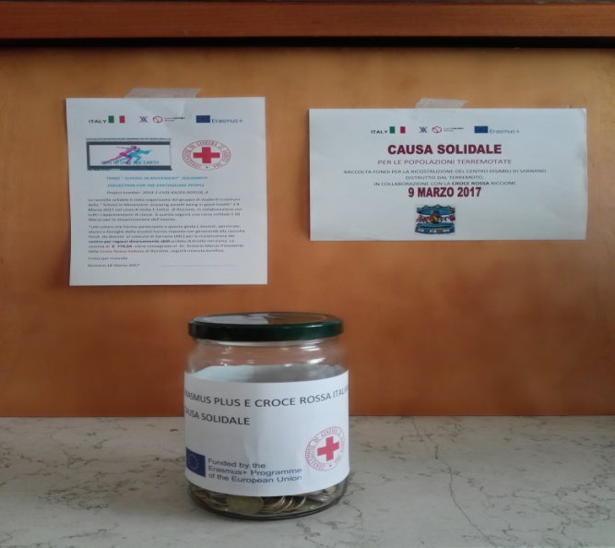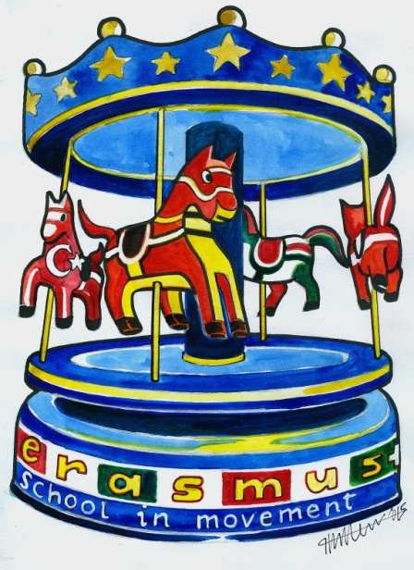On 9th March 2017 we held the collection of funds to finance the reconstruction of this Centre for young disabled people in Sarnano. All the 70 representatives of the students had previously conferred with our Director and teachers to organize the event. On 9th March 70 envelopes were distributed into all the classrooms and at the end of the school day they were sent to the teacher in charge of collecting all the money. Students, families, teachers and school staff all contributed to raising the funds. Zappia Ilaria from 5th Ds coordinated the work and the communication, we also created an event on the Erasmus+ facebook group to disseminate the activity.

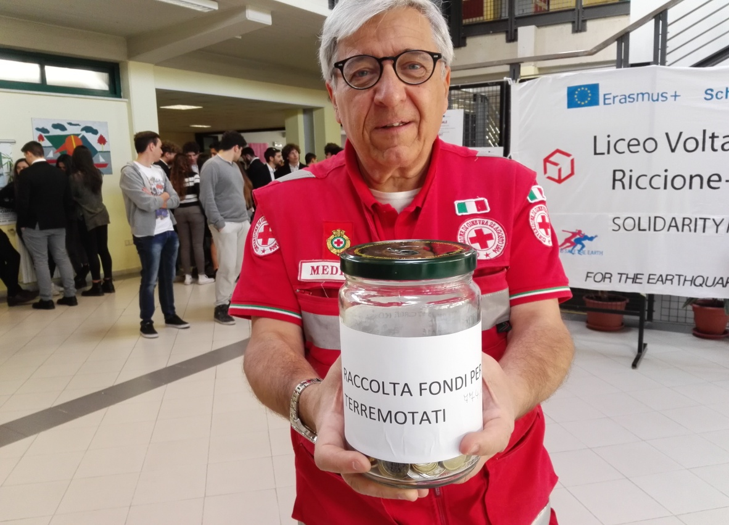

On 18th March the President of the Red Cross of our town came to school to receive the result of our efforts. We managed to raise 774,64€ and we were proud to welcome Dc. Manzo and hand him a big jar with all the money inside. He thanked us and told us how the money would be spent, we took some photos with him, our Director and teachers of the Erasmus+ Project and finally he signed the receipt of the donation. Here you can see some of the moments with him.

