

***School in Movement: enjoying wealth being in good health***

*Project number: 2014-1-ES01-KA201-003518_4*

***Italian traditional games***

In Rimini every year in Spring they hold an exhibition of traditional games in the Main Square of the town “Piazza Tre Martiri”. Children can take part in the games and they are given demonstrations of how they were played in the past outdoors or indoors, when electronics, mobiles and Play Stations didn’t exist yet. Mainly these games were made of wood or of materials one can find in the home. They are simple but, as you can see from the photographs, they can become very involving.

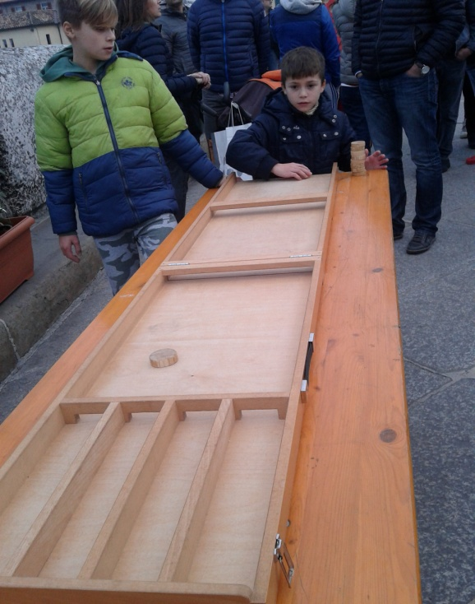 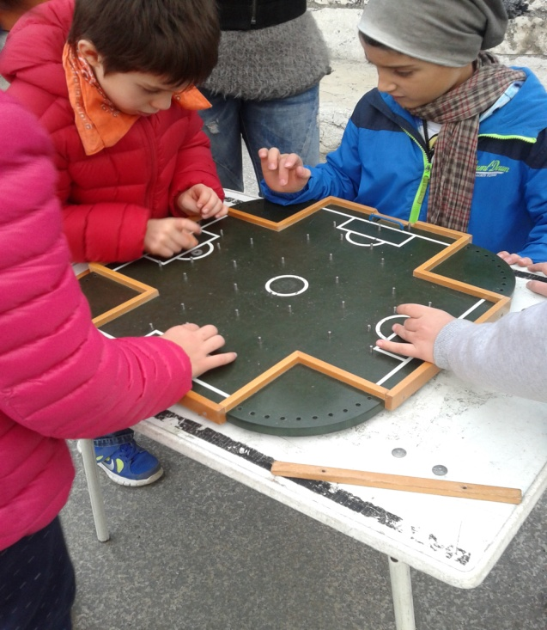

Children use their hands and play in groups so that they also learn to socialize in a world where entertainment has become a lonely activity. Our favorite games when

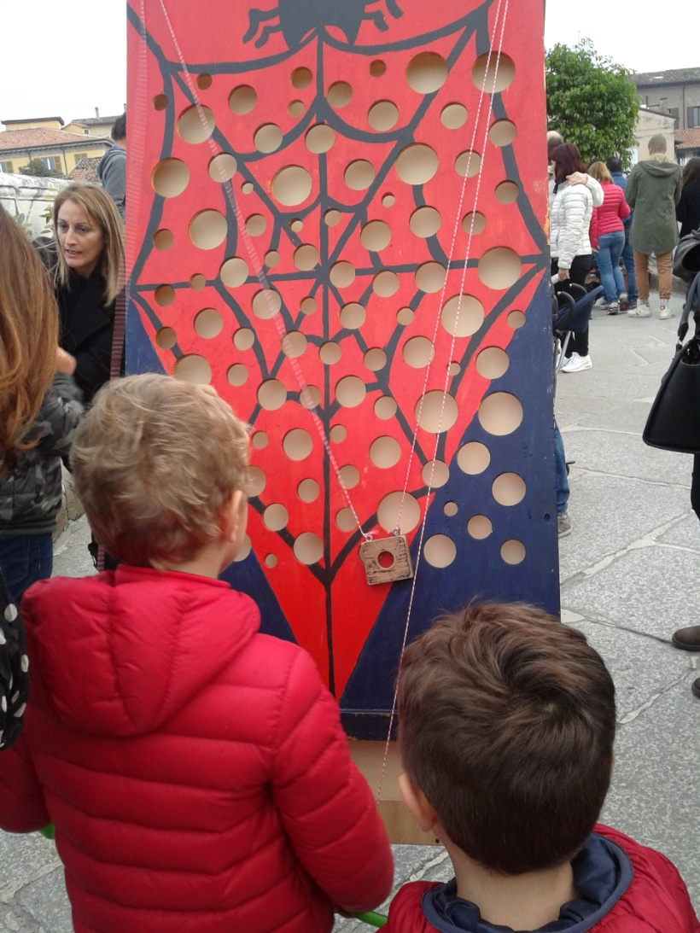we were small, were jumping the rope, playing with marbles on the beach, playing bocce on the sand, hide and seek, poisonous ball, handkerchief, and so on….Certainly every nation and region have their own names for these games. We spent whole summer afternoons running and 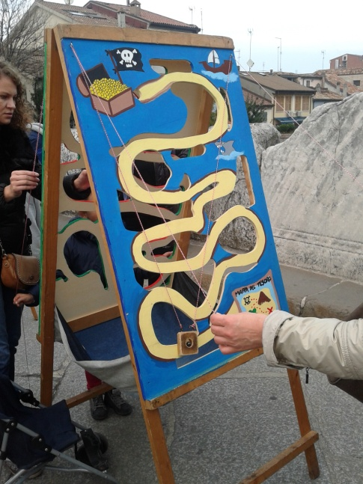playing outdoors….it was very healthy, indeed!

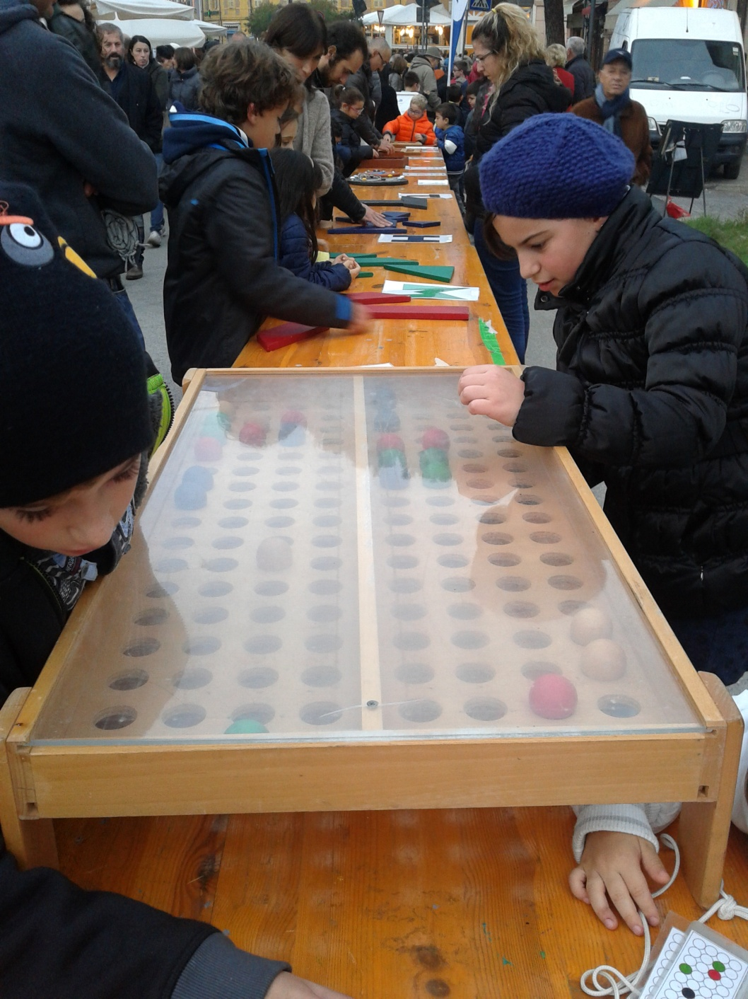These children are very concentrated, their attention is completely taken and they look very absorbed, they are doing a very useful manual activity.

Another catchy game that we used to play in summer time is called “ table football”. It’s very common in our region “ Romagna” and traditionally is played at the seaside. If you really want to have fun you need 2 teams of 2 players, a small hard white ball and the table football you can see in the picture below. This playing board is very resistant , made of plastic, wood and metal. The balls are 10 in all.

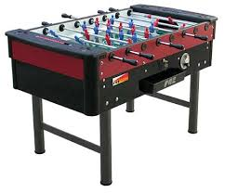 You throw the first ball into the middle of the table and you must try to score into the opponent’s goalkeeper’s door. The doors are at the 2 ends of the table.

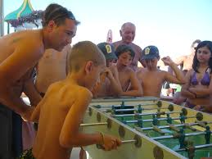You move the ball by twisting your wrists that hold the handles of a two metal rods. There are 8 rows of “ foosmen” made of hard plastic fixed on the metal rods. The winning team is the one that scores the most goals, obviously. You need fast reflexes, concentration and good aim! 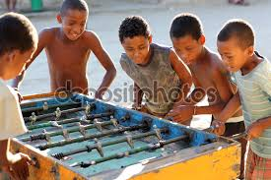

*Edited by 4thAs corrected by the English teacher.*