 ***LICEO “A.VOLTA-F.FELLINI”***



Erasmus+ School in movement: enjoying wealth being in good health !

NUMBER OF THE PROJECT: 2014-1-ES01-KA201-003518_4

***Treasure Hunt!***

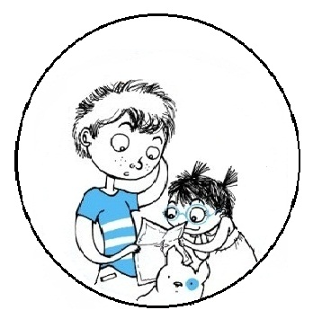

**Are you ready?? Let’s GO!**



**Replace the result of the expression with the corresponding letter and find the hidden words:**

A=2 E=8 I=40 0=19 S=49 Z=60

B=5 F=9 L=24 P=3 T=25

C=6 G=13 M=32 Q=7 U=55

D=1 H=10 N=4 R=47 V=-11

° 2+3-5x3+4:2-3=

°20+3-(6x5)+(25+60+((13x3)+57+))x0+47=

°2^2x√(9)+ √(36) x2=

°((13x4):2)-2=

°(√(196)):7=

°6x7+2+2^3-(2√(5))^2=

°5x√(121)=

°7^2=

°2x4+27-56+2x7+53=

°3^2x2+1=

°12x2=

°88:11+6^2-4=

°(14:6 + 5:3 - ( 3 – 5:3 ) + 12:10 ) – 2:3 + 8:10 =

°(20+20)x0+40=

The hidden words are: ________________ _________________



**Delete all the letters repeated for each row and find the hidden words:**

B G E R C E D O B D M D G A C G B E S D

S I H Q U L M A N N L R H M I H E H M

The hidden words are: ______________ _____________



**Write twenty words that all begin with the letter H and you will be told where to go :**





**Guess the place to go with the suggestions:**

° A monument with water, where tourists go to take some photos

WITH

°A little spherical thing which is in the oysters and it is really precious

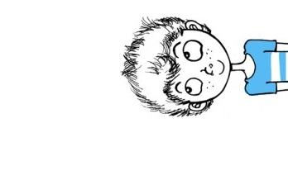



**Connect the dots and the team that will finish first will be told where to go**

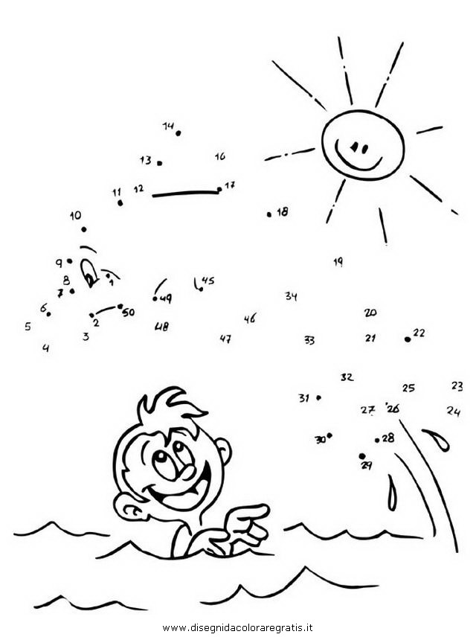



**Guess from the photo where to go**

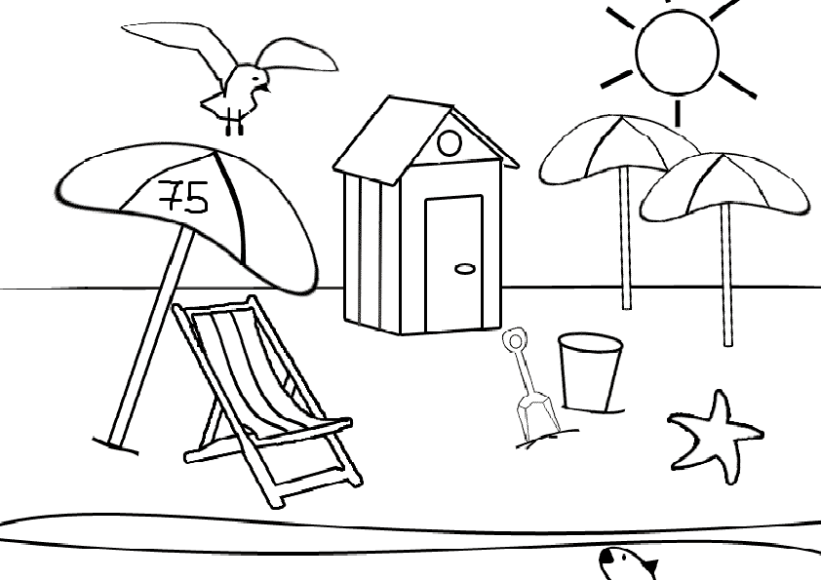



**Write the European capitals in the respective boxes and you'll find in the highlighted box where to go**

1. Russian capital
2. Portugal capital
3. Turkish capital
4. Italian capital
5. Danish capital
6. French capital
7. English capital
8. Spanish capital
9. Romanian capital
10. German capital



**Answer the riddles and you will be told where to go**

What goes up and down but never moves? ____________________________________

You look at me to see yourself ______________________________________________

What goes up when the rain comes down? ____________________________________

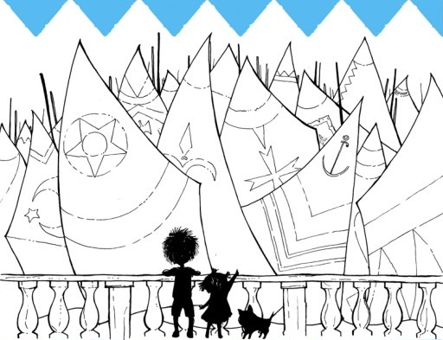



**Solve the acronym**

Very Important Person

Water frozen in Water frozen in the solid state

Possessing live

A workplace for the conduct of scientific research

An athlete who performs acts requiring skill and agility and coordination

A think that you usually eat in summertime after you had lunch/dinner or for break

Blood’s color

A fruit that can be red, green and sometimes yellow

A negative adverb used to express dissent

What you used to pay something

You used it to see

You do it when you are in swimming pool

Usually a rabbit eat this

It isn’t your home but you can sleep here when you are on holiday

A very big ice’s pierce



Good Luck and Have Fun!

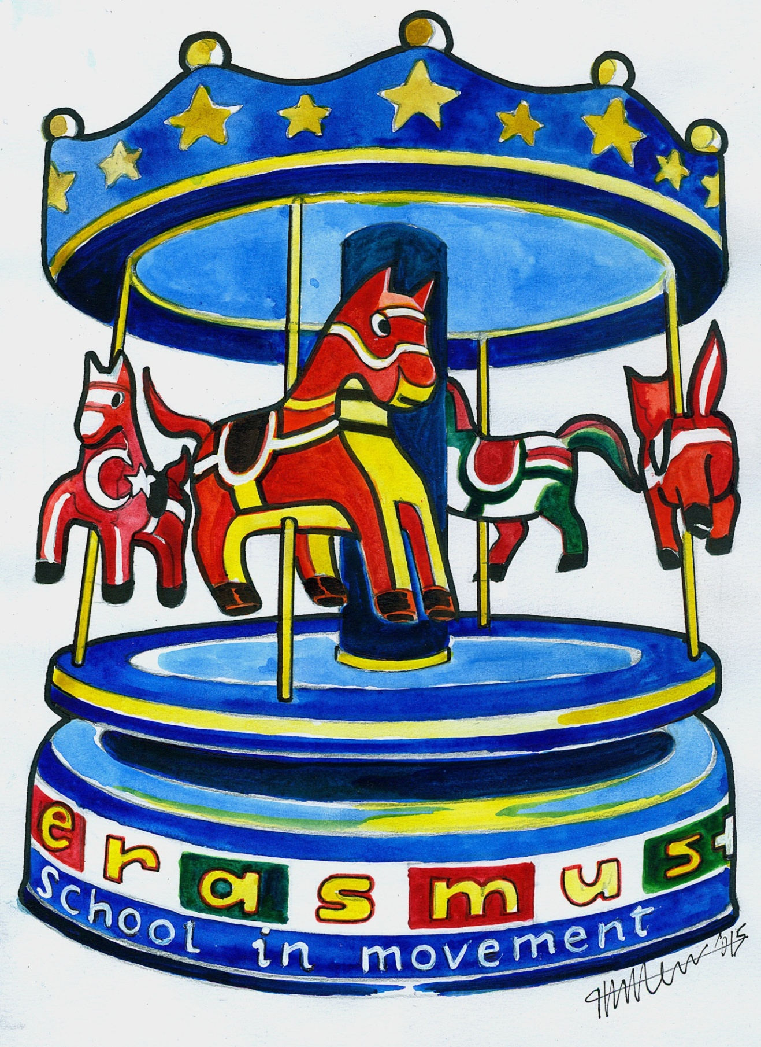

 **BY gaia barbari 3^d**