

***SCHOOL IN MOVEMENT: ENJOYING WEALTH BEING IN GOOD HEALTH***

Project Number: 2014-1-ES01-KA201-003518_4 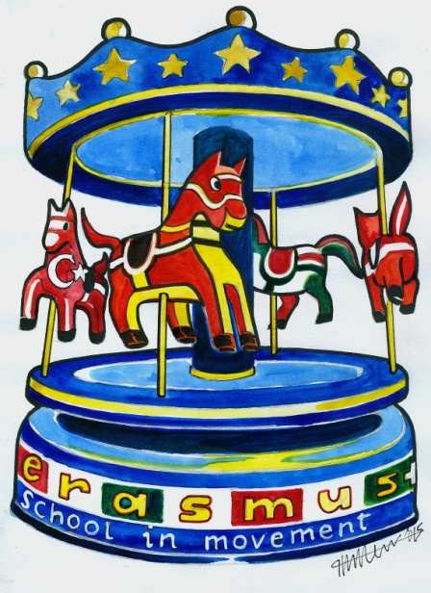

***NEWSLETTER***: Testimony at school with the guys from the

“ We Free “ Project of the San Patrignano Centre of Rehabilitation

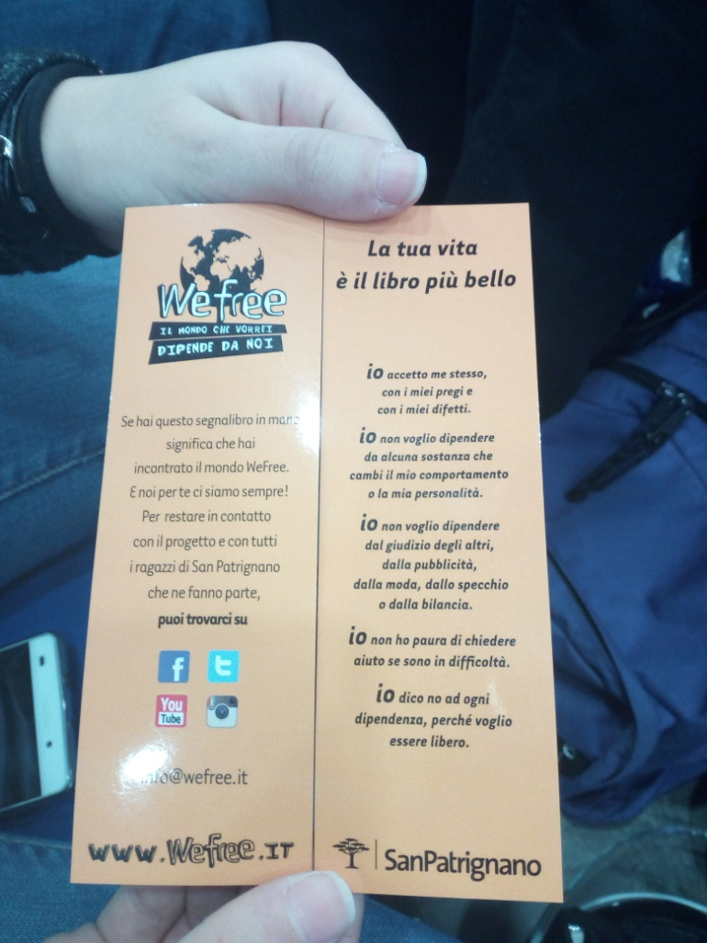

On 27th March, from 11:00 to 13:00 we attended a meeting from some guys of the San Patrignano Community and Centre of Rehabilitation. Marco told us his story of redemption. He is a 36 years old man who started his rehabilitation Program in San Patrignano in 2012 and finished in 2016.

Even though he had a nice childhood he suffered from a psychological trauma after his family had to go back to Calabria for working reasons. Here, in primary school he was bullied by other children and so developed a sense of distrust towards people, which never left him. At the end of primary school he got into music and formed a band. All of his friends wanted to imitate their rock stars idols and so they took up drugs: first weed and light drugs, then also alcohol and heroin.

Together with a friend, Manuel, he went to Florence where they got a music contract and published a CD. They went on using drugs but suggested cutting down on them. As Marco didn’t agree, he decided to leave the Band and go back to Calabria. He was broke and disappointed: his dream had been shattered. His parents felt let down by him. Marco was deep into heroin by now, he felt a sense of failure, he wanted only to feel nothing and heroin helped. He started to exploit his parents who had become a sort of “ cash machine” for him. He lost contact with his sister, too. He was always between jobs and stoned most of the time.

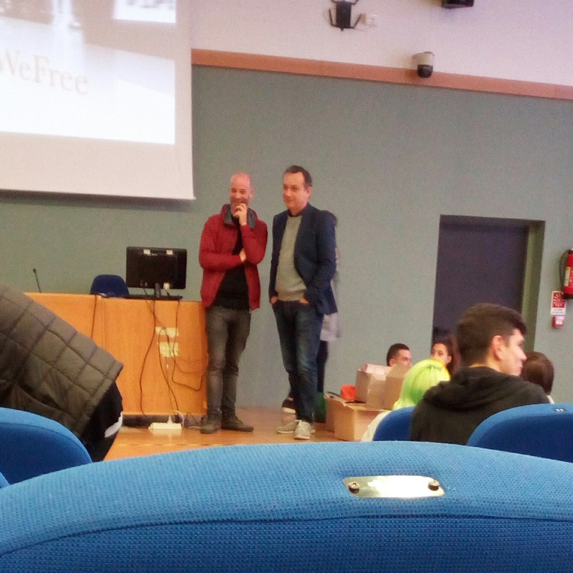*Moments of the Testimony*

One night at the pub he felt really sick and fainted. But he went on taking more and more drugs of all types. He started stealing everywhere to get the money for the drugs. Finally he was caught and brought to jail. When he got out he decided to come back to his father and tell him everything. His Dad suggested that he goes to a Rehab. Community and he agreed initially only to make him happy. He applied for San Patrignano and was accepted.

Here he was put to work with horses. He couldn’t see his family for a whole year because this is the rule. After 1 year his Dad died and Marco was tempted to go away but then he changed his mind and completed his path of recovery. Now he has found a girlfriend and lives and works in Riccione with her.

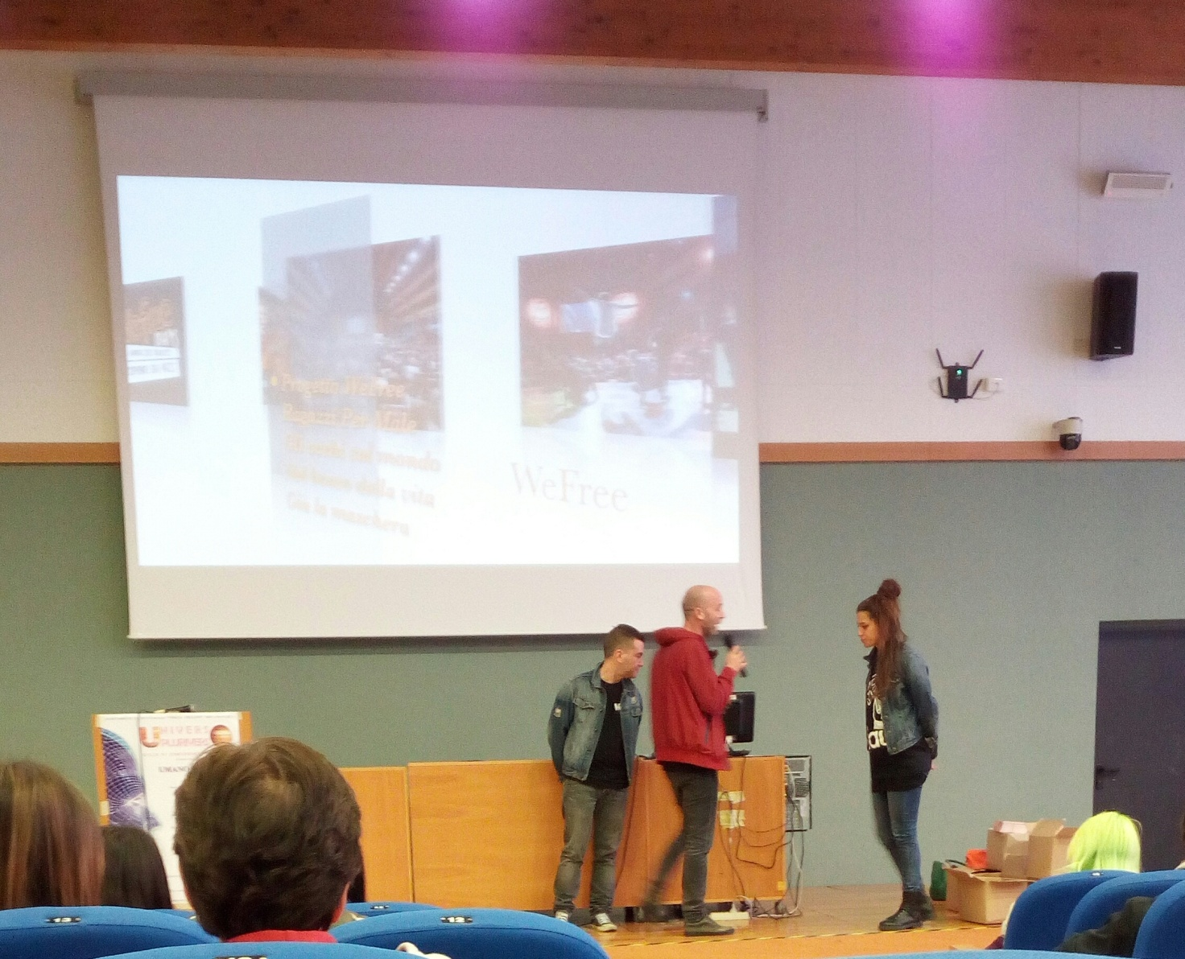

This is a photo taken at the Meeting/Testimony on 27th March 2017 in our school “Liceo A. Volta-F. Fellini” on the Theme “ Abuse of drugs and substances: Uneasiness in adolescence, the drama of existence in youth. A path of recovery and redemption in San Patrignano”

***MARCO BADLY MISSED SOMEONE TO TALK TO AND LOTS OF THE YOUNG PEOPLE IN SAN PATRIGNANO ARE EXPERIENCING EXACTLY THE SAME THING!***

***We are not different from them! Edited by the students of 4thAs***