

**PROJECT: “ SCHOOL IM MOVEMENT: ENJOYING WEALTH BEING IN GOOD HEALTH “**

**2014-1-ES01-KA201-003518_4**

DISSEMINATIon

These are only some of the articles that we got published along the three years of the Project’s life. In this first page of newspaper, the picture in the middle of the second row is about the “ Full Healthy Breakfast “ we had in 2015 at the vocational tourist Institute “Malatesta”.

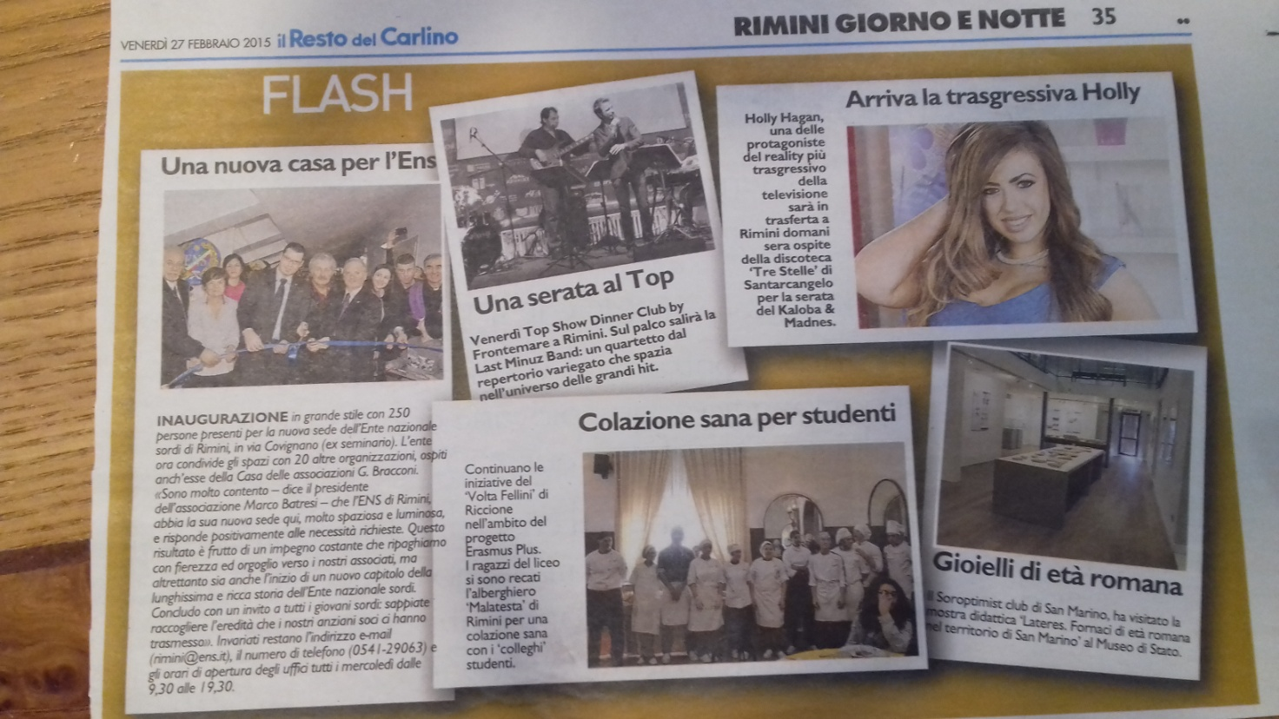

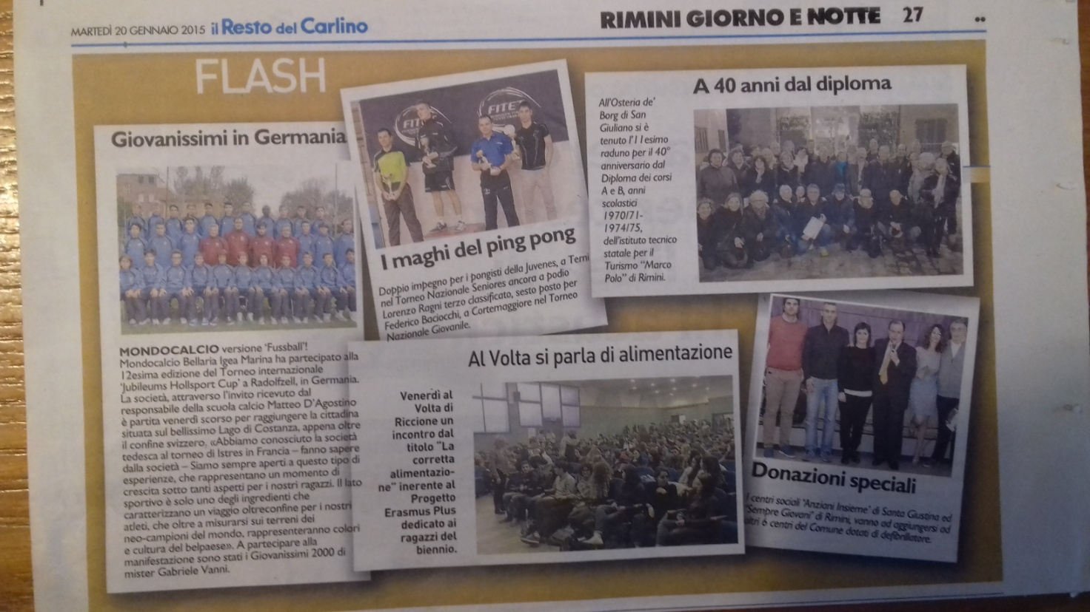

**The picture in the middle of the second row disseminates the conference we had on nutrition with experts, which took place in January 2015.**

The picture below concerns the conference we had in the Auditorium of our Liceo Volta-fellini, with a group of Pharmacysts who lectured us on “ Healthy Nutrition associated with sports activity”. The conference was followed by questions and a debate and suggestions were given for a healthy lifestyle for our teenagers.

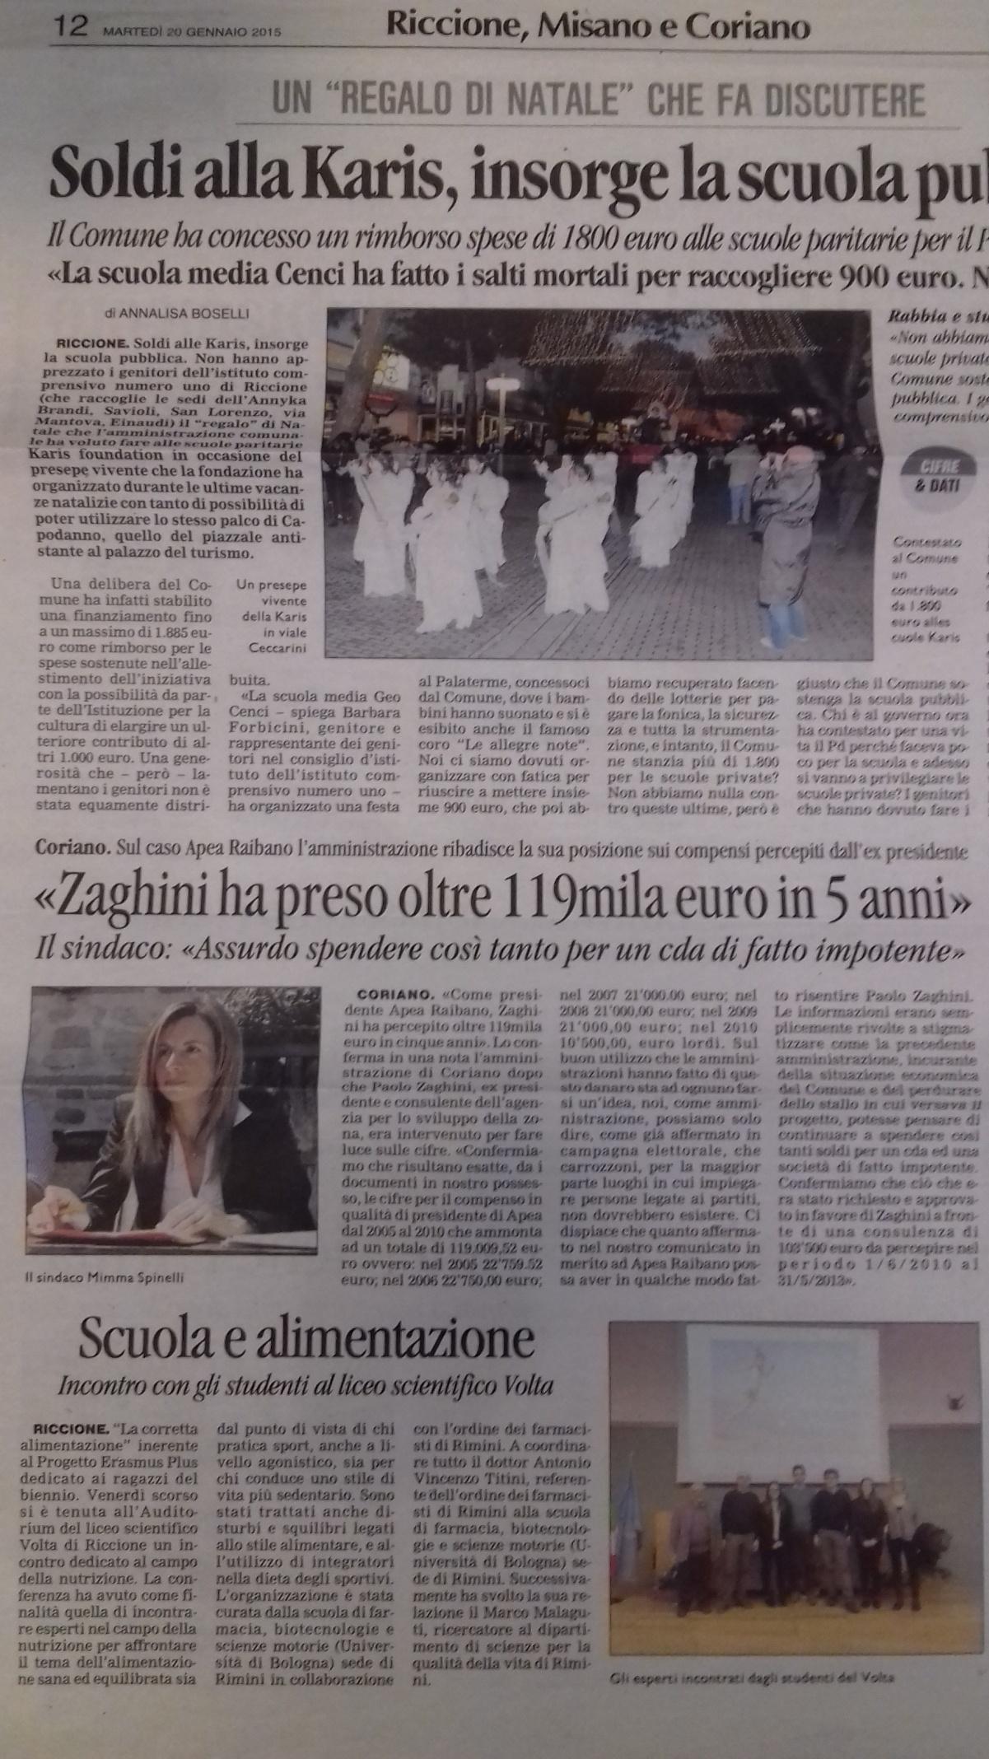

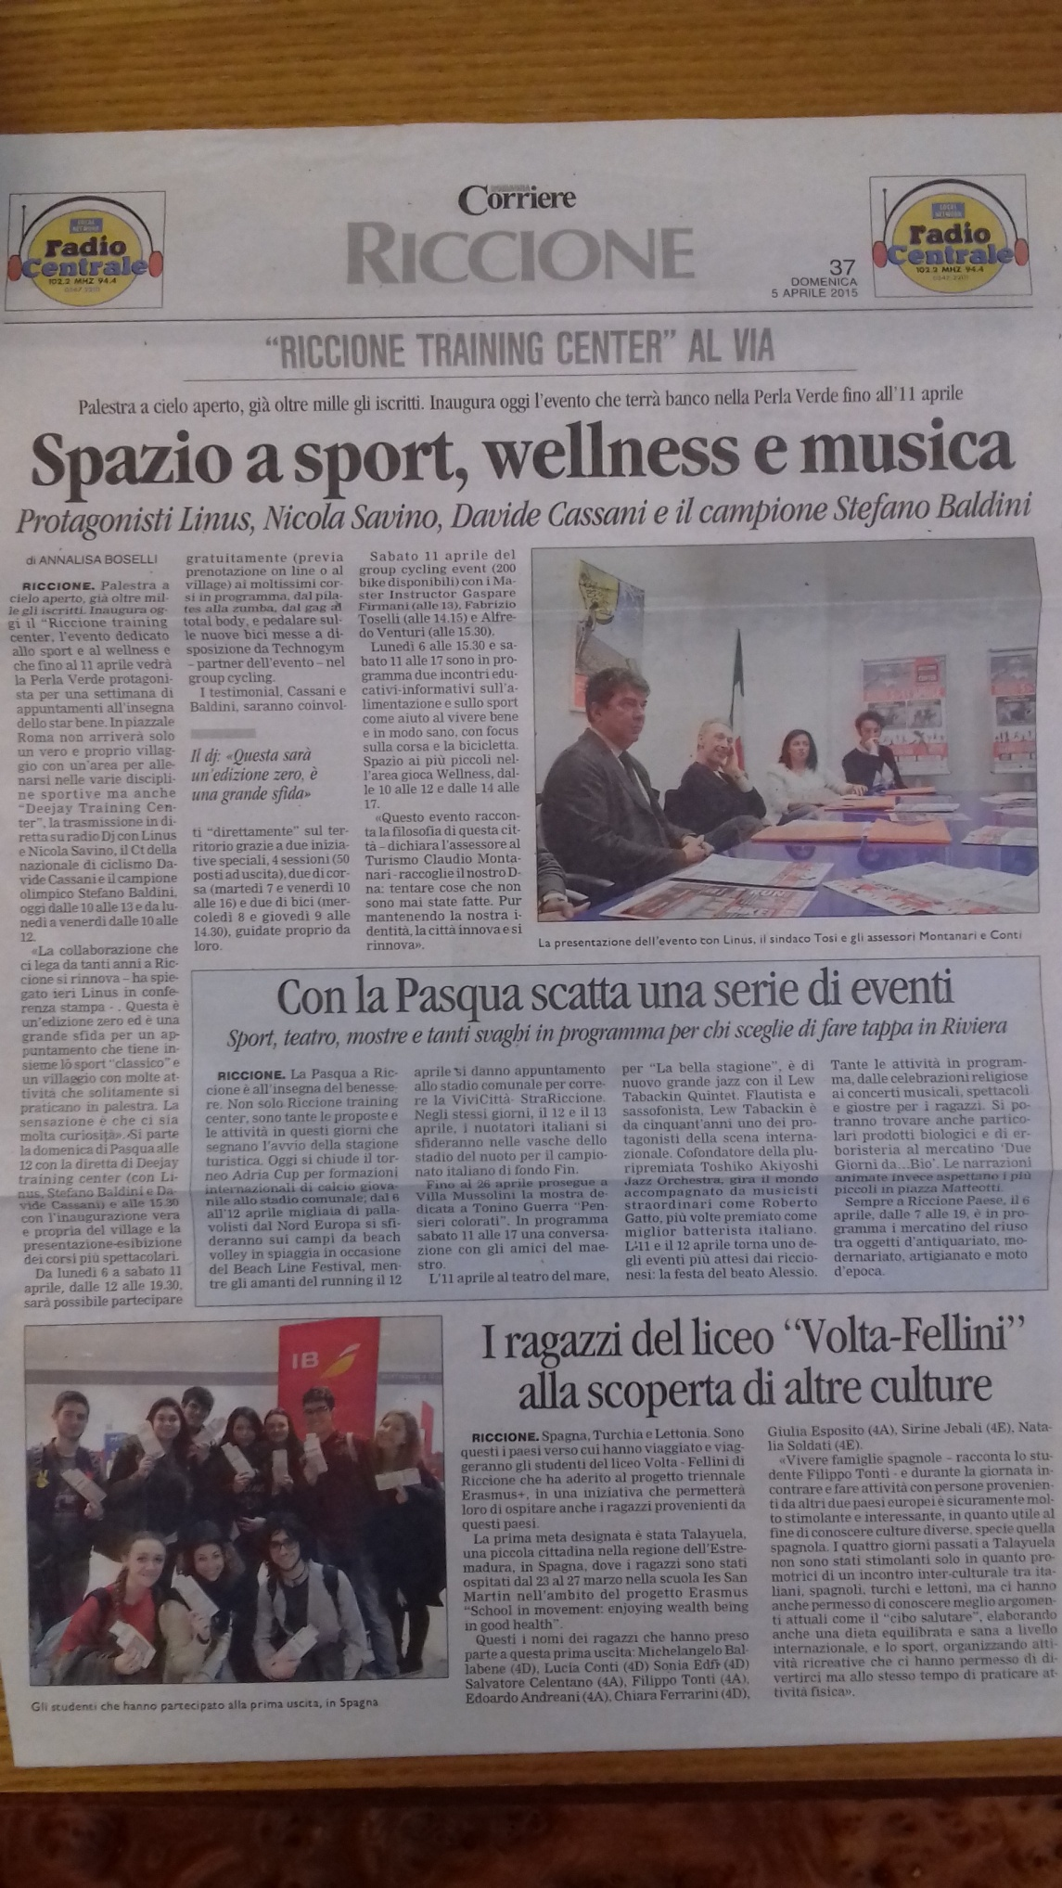**This newspaper page disseminates the first teaching, learning, training activity which took place in Spain.**

*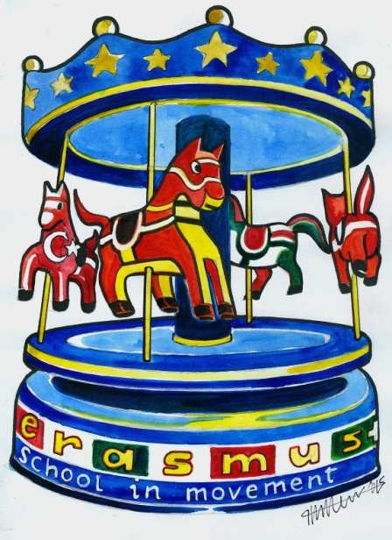Our students ready to leave for Spain.*